



**DECEMBER ‘15**

Story Book

Who Came?

7 of you attended.

There were THREE possible venues - Tiverton, Bideford and Newton Abbot.

Valerie Cannon, Marion Martin and Karen Morris attended from the Senior Management Team.

[](http://www.google.co.uk/url?sa=i&rct=j&q=&esrc=s&frm=1&source=images&cd=&cad=rja&uact=8&ved=0CAcQjRxqFQoTCKTH6IX0lMkCFQJNGgodnr4GnA&url=http://cliparts.co/picture-of-cartoon-eyes&psig=AFQjCNGV5SuLKRlX4171YOjRIXs34ZcK2w&ust=1447761972446143)**The focus of the meetings was the PLEDGE**

**REVIEW**

Devon’s commitment to our children in care ….

Did we keep our promises?

**We based some CICC meeting activities around games!**

Our promise about your safety

****This activity was based around

“Top Trumps” with you choosing

an avatar and giving a score out of

20 for how safe you feel based on

information you’ve been given:

*Average score*

* Confidence 17
* Staying over at friends 14
* Internet safe 16
* Sex & relationships safe 16
* Being bullied 14
* Making your own decisions 13
* Identity not given “out” 16
* Explanations given about decisions 14

Our promises to you about your health &

wellbeing

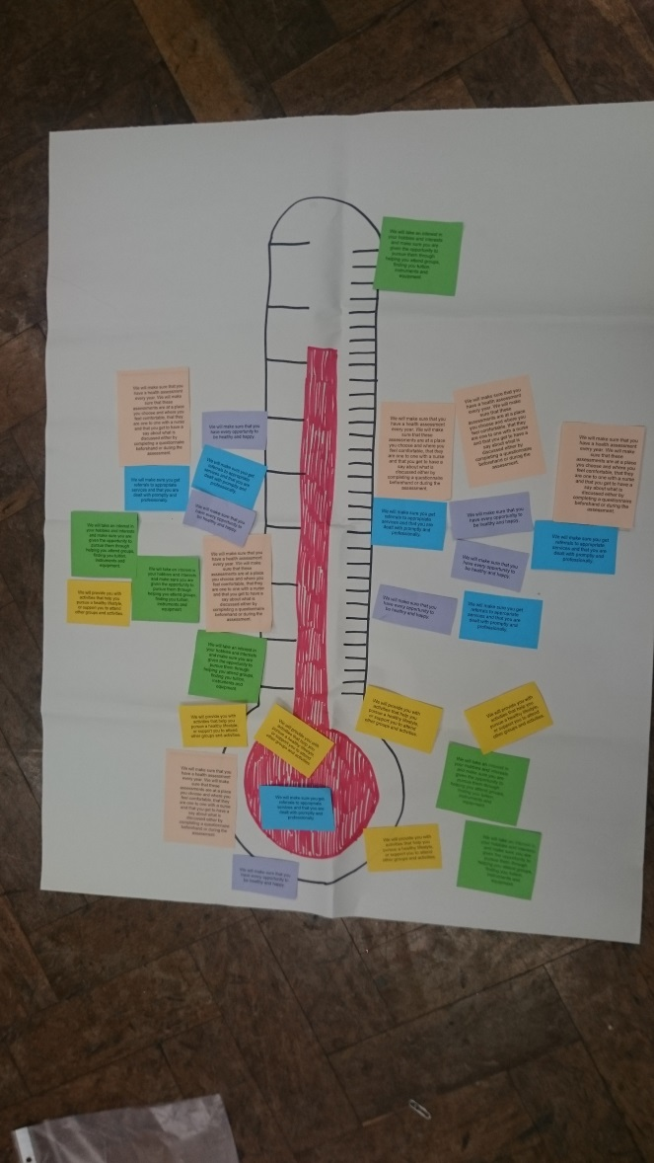

**We will make sure that you have every opportunity to be healthy and happy.**

**We will provide you with activities that help you pursue a healthy lifestyle, or support you to attend other groups and activities.**

**We will take an interest in your hobbies and interests and make sure you are given the opportunity to pursue them through helping you attend groups, finding you tuition, instruments and equipment.**

**We will make sure you get referrals to appropriate services and that you are dealt with promptly and professionally.**

**We will make sure that you have a health assessment every year. We will make sure that these assessments are at a place you choose and where you feel comfortable, that they are one to one with a nurse and that you get to have a say about what is discussed either by questionnaire beforehand or during the assessment.**

**Giant thermometer**

**You can already see the trends!**

You think Devon is WARM at giving you opportunities to be healthy and happy. We are COLD at providing you with activities that help you pursue a healthy lifestyle. Oh No! We are LUKEWARM at taking an interest in your hobbies and interests.

Our referrals to appropriate services are WARM and we are WARM at making sure you have a health assessment every year.

Our promises about where you live

This activity was based on the game “Who wants to be a millionaire?” The game showed if young people were aware of what is promised in the Pledge. The £million question was, “Is this your experience?”

**What you told us:**

**“I’ve never been to see a placement ahead of moving in”**

**“I don’t get options about where I should live.”**

**“My views are always ignored.”**

**“I’ve had to move schools lots when I’ve moved placement.”**

Our promises about

**Social Worker Profile**

**Tasks:**

1. Write down exactly what young people say
2. Provide info and up to date contact numbers, especially out of hours
3. Treat you fairly
4. Listen to young people and understand what they are saying
5. Help young people understand their life story

**Skills/qualities:**

* Someone who sticks to their promises and to policy
* Good communication skills
* Someone who does what they say they will
* Prioritise
* Someone who doesn’t make excuses
* Someone who doesn’t look down on young people
* Good listening skills

those who work

with you

**Based on the promises in**

**the Pledge, we asked you**

**to describe the job a**

**Social Worker should do**

**(your top 5 priorities), to**

**say what skills/qualities**

**social workers need to**

**do the job and a training**

**programme (before or on**

**the job).**

If you were designing a training programme for social workers you would include sessions on:



Know policy

Listening skills





How to do

reviews

and big

meetings

eg. roleplay

How to write

down what is

said

You also said:

* **After a big meeting someone independent needs to come and talk to the young person.**
* **Have volunteers to answer social worker’s phone if they are not in the office.**

We have passed all this info onto senior managers and will ask them for their response in a couple of weeks.



We look forward to seeing you at the Stand Up Speak Up Children in Care Council next time where you can….

* Tell Council managers what you think they need to know
* Have your say on things that affect you and your peers
* Learn new skills in debating and public speaking
* Enhance your CV
* Meet new people and make new friends ....

14th March 4.00-6.00pm Exmouth

15th March 4.00-6.00pm Barnstaple

16th March 4.30-6.30pm Okehampton





* Meghan Read – Participation Worker

[meghan.read@devon.gov.uk](mailto:meghan.read@devon.gov.uk) 07817010997



* Lizz Williams – Participation Worker

[Elizabeth.williams@devon.gov.uk](mailto:Alison.duckers@devon.gov.uk) 07891 512344

* Rich Green – Participation Worker

[rich.green@devon.gov.uk](mailto:rich.green@devon.gov.uk) 07855 516354

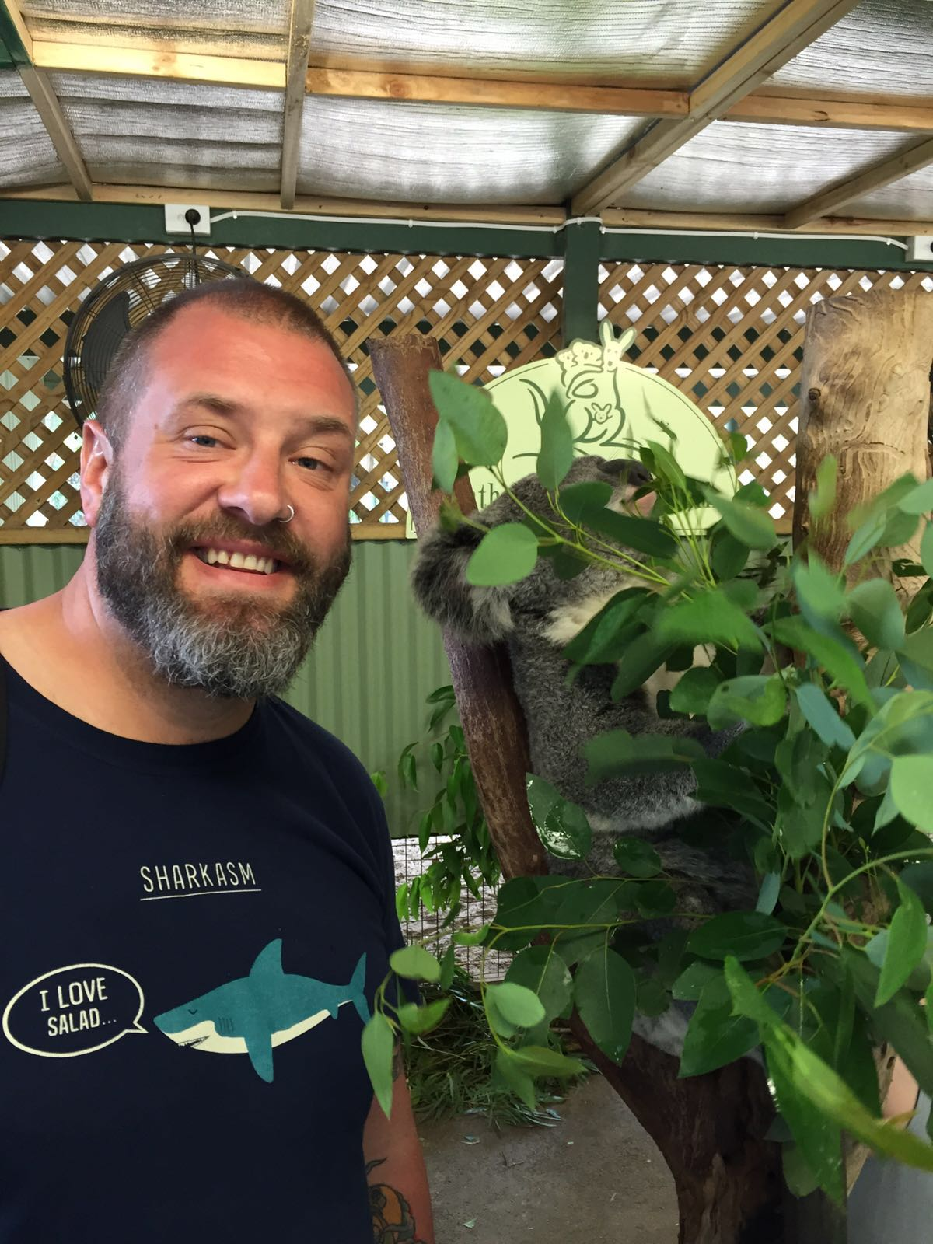





1. Join a participation group:

Age 7-11 Stand Up Speak Up Club

We write to you

Age 11-16 SUSU Participation Forum

Rio group in Exeter. Jam group in Bideford.

A new group starting September in Totnes, name to be decided by you!

[](http://www.google.co.uk/imgres?imgurl=http://images.sodahead.com/polls/000298869/polls_debate_5428_517086_poll_xlarge.jpeg&imgrefurl=http://www.sodahead.com/fun/when-debating-with-people-do-you-usually-try-to-do-it-in-a-polite-way-or-do-you-ever-personally-ins/question-298869/&h=350&w=350&tbnid=8tEX5RbdGzXp3M:&zoom=1&docid=lbkNtenW6iya9M&ei=1weMVeyRLIyR7Aaayo3wBg&tbm=isch&ved=0CFoQMygwMDA)Age 16 – 21 Care Leavers Forum

In Exeter, Bideford and Totnes

1. Come to the Corporate Parenting Board
2. Come and interview potential new staff
3. Deliver training to staff
4. Come to one of events and participation days
5. Read our participation newsletter and reply to letters asking your opinion
6. Use MOMO or visit [www.standupspeakup.org.uk](http://www.standupspeakup.org.uk)
7. Encourage other young people to participate
8. Your ideas

CookieMonster